Volunteering at the Hope Centre
The Hope Centre started in March 2020 as the Covid-19 pandemic triggered lockdown in the UK. The Hideaway in Partington launched the Hope Centre project as a temporary community response hub, co-ordinating volunteers to provide shopping and food support, meals, calls and errands. Since then the Hope Centre has provided support valued at hundreds of thousands of pounds; providing a vital lifeline for thousands of local residents.
In 2021 as the focus moves to long-term support and recovery, the Hope Centre is establishing a permanent base in the heart of the Partington community. Run by the community, for the community, through friends, partners and supporters the Hope Centre plans will support all who need it within the local community. It will provide a base for:
- Affordable groceries for all - £3 for a large bag of shopping valued at £35-£50
- Single and low quantity items – just what you need
- Delicious, healthy, fresh cook-at-home meals
- Second-hand school uniform
- Brew bar – a listening ear, signposting and advice, a range of help drop-in over a brew and cake
- Credit Union
- South Manchester Food Bank
- The Bread and Butter Thing
- Local makers’ market
The Hope Centre will work hand in hand with the Hideaway and other local organisations in our community.
Get Involved
We’re looking for a fantastic team of volunteers who can help with the running of the Hope Centre. Whether you can give a couple of hours each week or more, we’d love to hear from you.
All our volunteers will be trained in the relevant areas and given a Hope Centre uniform and ID badge. Volunteers automatically become part of the Hideafamily – our growing network of paid and unpaid staff who are equally valued and crucial to the success of our mission. We love to invest in all our team members which means volunteers can access all our training, groups, have their own mentor and receive as much support as any of our service users if it’s appropriate. A DBS check may be undertaken for roles working with vulnerable adults.
The centre will operate Monday-Friday 9.30am – 4pm.
Roles and responsibilities
The following roles are all needed to make the Hope Centre as success. Volunteers may wish to do one, a few or most of these roles.
- New member registration – chatting to new members, explaining our services and signing them up.
- Check-out – using our till and check-out systems to enable people to pay.
- Restocking – taking deliveries, restocking shelves, tracking inventory.
- Delivery driver – collecting food from donors and delivering food parcels where needed (van provided).
- Listener – our trained listeners will be there to chat, listen, advise, signpost, provide advocacy and on-going support, follow-up calls, help completing forms and prayer/pastoral support where appropriate.
- Mentor – Provide regular support and catch-ups, building an on-going, genuine friendship with those who would benefit from on-going support and encouragement.
- Washing and Ironing – Ensuring all donations of school uniform are clean, ironed and suitable for re-sale.
- Cleaning – Ensuring the space is clean, tidy and safe at all times.
- Supporter liaison – building and managing good relationships with existing supporters and donors, fundraising and seeking additional support.
- Credit Union team – A range of roles exist within the Credit Union team including managing cash, loans, record keeping, delinquency.
- Other specialist knowledge – Specialists and professionals in a range of areas such as counselling, business support, teaching, law, social services etc. may be needed and volunteers with specialisms allow us to provide a range of additional services and support.
If you have professional knowledge or experience you may be willing to offer free of charge we would love to include your details on a private database for our team to be able to make ad-hoc referrals as necessary.

Apply to be a part of the team
If you would like to apply to be a part of the team please complete the application form below and return it to hope@thehideawaymanchester.com
You will be invited to an informal get-to-know-you session either in person or via zoom. Following that potential team members will be invited to undergo relevant training and checks before working with our team. Thank you for being willing to help.

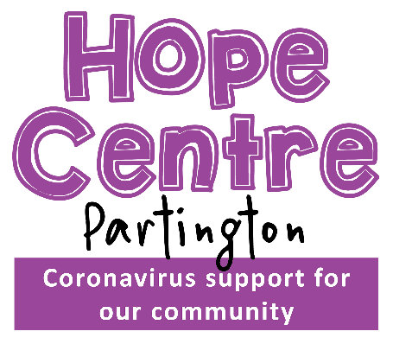
Hope Centre Volunteer
Application Form

Name

Address

Email

Phone

Which roles would you like to be considered for?
☐ New member support
☐ Check-out
☐ Restocking/taking deliveries
☐ Delivery driver
☐ Listener
☐ Mentor
☐ Washing and Ironing
☐ Cleaning
☐ Supporter liaison/fundraising
☐ Credit Union team
☐ Other (please tell us below)

How many hours each week would you like to volunteer?

When are you available for volunteering?

Please tell us a little more about yourself.
Do you have any relevant previous experience?

Why would you like to volunteer with us?

What do you hope to gain (or give) by working with us?

Do you currently attend a church regularly, and if so which one?

Would you be willing to undertake a Disclosure and Barring Service (DBS) enhanced check? ☐
Are you willing to undertake any training relevant to the role? ☐
Do you hold a full current UK driving license? ☐

Rehabilitation of Offenders Act
Under the provisions of the Rehabilitation of Offenders Act, you do not have to disclose information on certain convictions after a set period of time, as they become ‘spent’. However, this post is exempt from the above Act, therefore, ALL convictions and any cautions or bind-overs must be declared and cannot be regarded as ‘spent’.

Have you ever been convicted of a criminal offence? Yes ☐ No ☐

Do you have any criminal charges or summonses pending against you? Yes ☐ No ☐

Having a criminal record will not necessarily bar you from working with us.

Health

Please specify any special access
requirements you may have in
order to attend interview.

I confirm that the information contained on this application form is, to the best of my knowledge, correct and accurate. I agree to the information being processed in accordance with the Data Protection Act.

☐ Do you consent to have your details stored securely at The Hideaway in accordance with GDPR?
☐ Do you give your consent to contact you about your answers above?

Signed Date

Please return this form to hope@thehideawaymanchester.com

